Women in Physics in Japan
Mihoko M. Nojiri^{1, 3,a)} ,Nahoko Kasai^{2, 4, b)}, Atsushi Masuda^{2, 5}, Nobuyuki Matsuki^{2,6} and Takami Tohyama^{1, 7}
¹The Japan Physics Society (JPS), ²The Japan Society of Applied Physics (JSAP)
³KEK, Oho 1-1, Tsukuba, Ibaraki, 305-0801,
⁴NTT Basic Research Laboratories, NTT Corporation
⁵National Institute of Advanced Industrial Science and Technology
^{６} Kanagawa University, ^{７}Tokyo University of Science

^{a)}nojiri@post.kek.jp
^{b)}kasai.nahoko@lab.ntt.co.jp
Abstract. We present several recent survey data showing the gender inequality in scientific researches in physics. We use the JPS member record over 40 years to estimate the gender difference of obtaining academic positions. The record shows that the ratio for women remaining as JPS member is less than that of men by 30% throughout the past 25 years. The women left physics research with significantly higher rate over 10 years since they were admitted as s members of JPS. The result quantitatively shows the “leaky pipeline” problem of women physicists in Japan.

Gender inequality Seen in JPS member records
Each year, more than 1500 new members join as new JPS members, and the ratio of women is typically ~10% since year 2000. Majority of the JPS members belong to either a university or a research institution. The distribution of the age of the new members peaks around 23~24 in the period 2001~2016. The member record covers significant Japanese physics researchers. JPS has decided to investigate them to study the gender inequality in Japan.
Figure 1 (a) shows the fraction of the women by the year they joined JPS. In the upper line, the women ratio at the year joining JPS is given. Here we show the moving average for every 5 years. (We do not show the ratio by each year because the numbers of the women members are rather small.) The ratio increased significantly until 2000, but it remains around 10 % for the last 15 years. The lower line shows the ratio of the women members at the end of 2016 again by the year they became the JPS members. The ratio of the current women fraction divided by those at the year they joined is shown in Fig. 1 (b). It is around 70 % for the group joined JPS between 1990 and 2003. The figure indicates lower ratio of women obtaining the academic career than men in JPS, although government aims for the higher ratio of women researchers. The higher ratio for those joined after 2003 does not mean the improved situation for women; it is more likely that the women members in the age group are still quitting much faster than men in the same age group.
One can see from Fig.1 (b) that the fraction of women have not been decreasing for those joining the JPS around mid 80’s. The generation gets PhD when there were relatively many open positions in the universities. Later in ‘90s, number of graduate students increased drastically, leading higher competition among those seeking research positions. Because of these external situations, the fraction of members who remain JPS today varies drastically with the year they joined the JPS. (See Fig. 2). It should be noted that the difference between men and women expanded in the period.

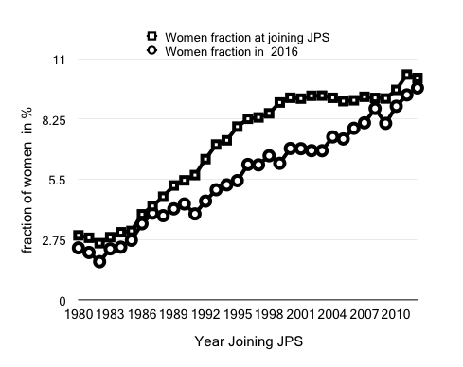 | 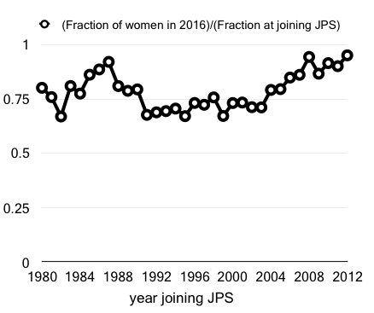
(a) | (b)
Figure 1. (a) Fraction of the women members of the JSP by the year they joined JPS (the upper line), and the fraction of the current women members. (b) Fraction of the women member in 2016 divided by the fraction at joining the JPS. The 5-year moving average stating the year indicated in horizontal axis is shown because of the smallness of the women fraction of the JPS.

The interpretations
The significant in equivalence between men and women JPS members may have come from the social demand, the biased view, and the under-representation toward women researcher in Japan. However, the difference between men and women in career building starts earlier than graduate level in Japan, namely, in the education in high school level or earlier. For example, women fraction is lower in more competitive university in Japan; recent statistics shows that the women ratio 44% in all Japanese universities [1], while it is around 20% for the two most competitive ones. This low women ratio indicates that experiences and human network may be limited for average women graduate students.
The fraction of women undergraduate students in science major is 34.3% in universities, while the women fraction in JPS is much less than that. The fraction among faculty level is even lower. The non-student women fraction is 4.9 % for the JPS members who belong to the 12 national universities that established PhD course before 1995 (“major” universities), while it is 7.7% for 26 national/public universities that have established PhD course between 1995 and 2007. This means that the women fraction is lower in the major universities and they do not meet appropriate role models of women researcher in their fields.
The similar survey is on going for the Japan Society of Applied Physics (JSAP). While JPS members are oriented to pure physics research, JSAP are more focused on applied physics. About 1/3 of member belongs to companies. Women fraction is also small, 4% for members in private companies, and 6% for those in universities. Because the members belonging to the companies are significant, the JSAP member data may reflect gender equality in Japanese industrial environment. However, analysis similar in JPS is not adequate to measure gender equality for JSAP. Unlike the JPS, there are personnel exchanges between companies and universities. There is also a tendency that the members in companies stop research by changing their specialties and/or by the promotion to management positions. The tendency should also be taken into account in the analysis and interpretation.

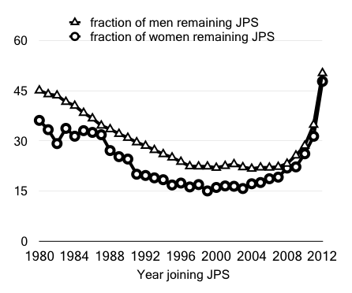

Figure 2. Fraction of the current JPS members among those joined JPS for men (the upper line) and for women (the lower line). The 5-year moving average stating the year indicated in horizontal axis is shown because of the smallness of the women fraction.

Role of the jps and JSAP
The JPS and JSAP have been recognizing the situation of the women in physics. Our activities include 1) summer schools for junior high and high school women students, 2) the daycare at annual meetings in both societies, 3) organizing diversity related symposiums in annual meetings 4) corporation with other societies in Japan though Liaison Association Committee for Promoting Equal Participation of Men and Women in Science and Engineering (EPMEWSE). The Liaison conducts survey among 90 societies, more than 15,000 researchers in Japan every four years, to propose policies for gender equality to the government. Most recent survey results will also be presented in this meeting.

References
- Portal site of official statistics of Japan. http://www.estat.go.jp

